# How to enter an expense report in vision:

* In the Info Center, go to Time & Expense
* Choose “Expense Report”
* The Expense Report will default to the owner logged into vision, if you’re making your own report, select “new”.
* If you’re making an expense report for someone else, you’ll have to search for their name in the “employee” section before choosing “new”.

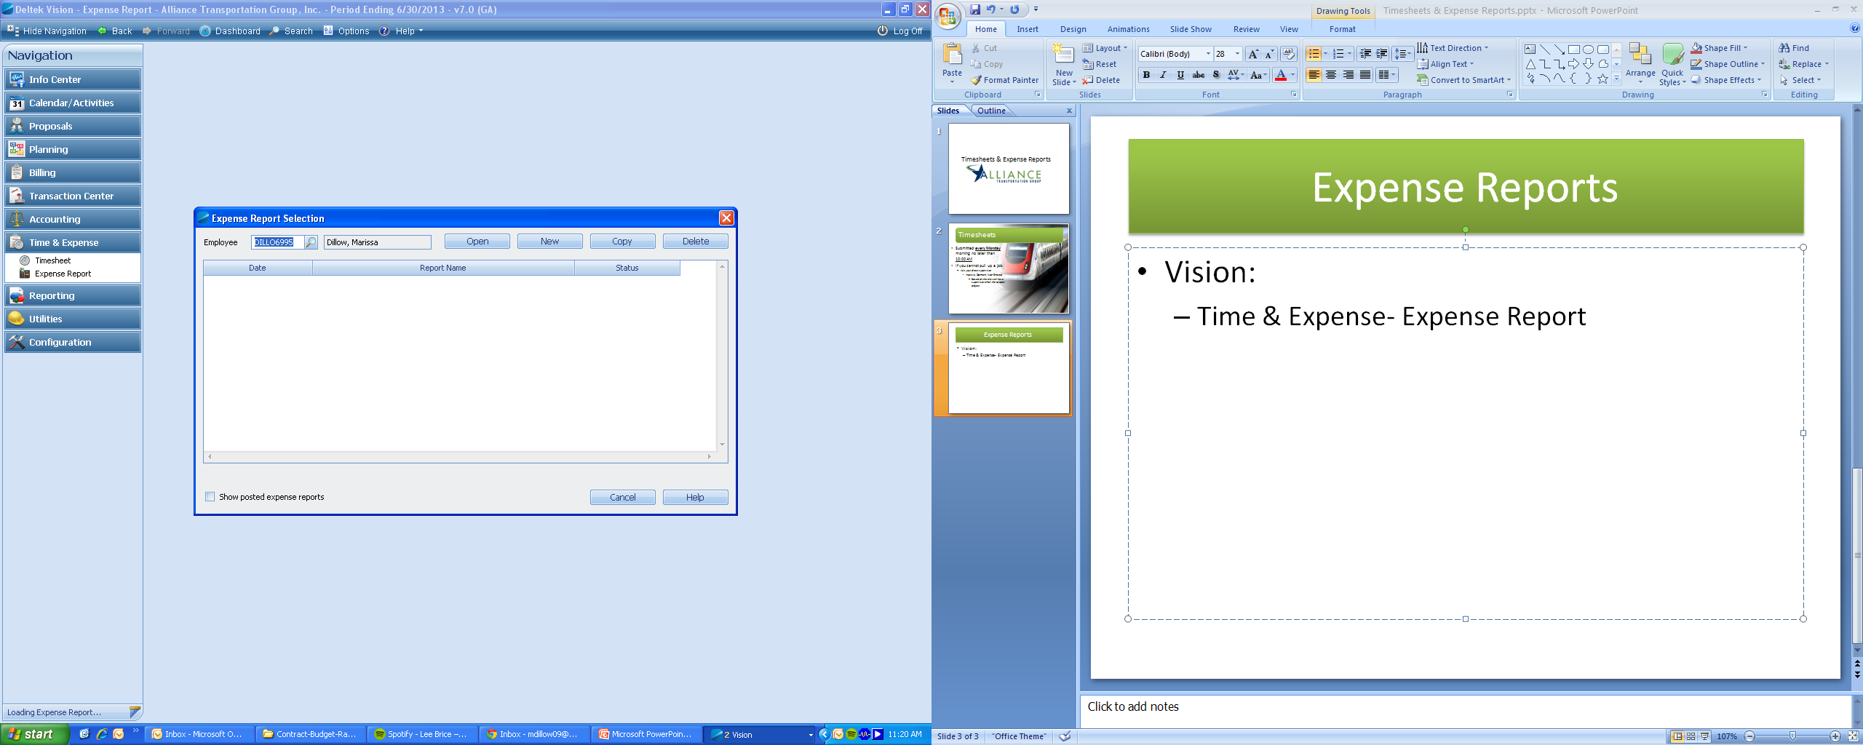

# The Sections of an Expense Report:

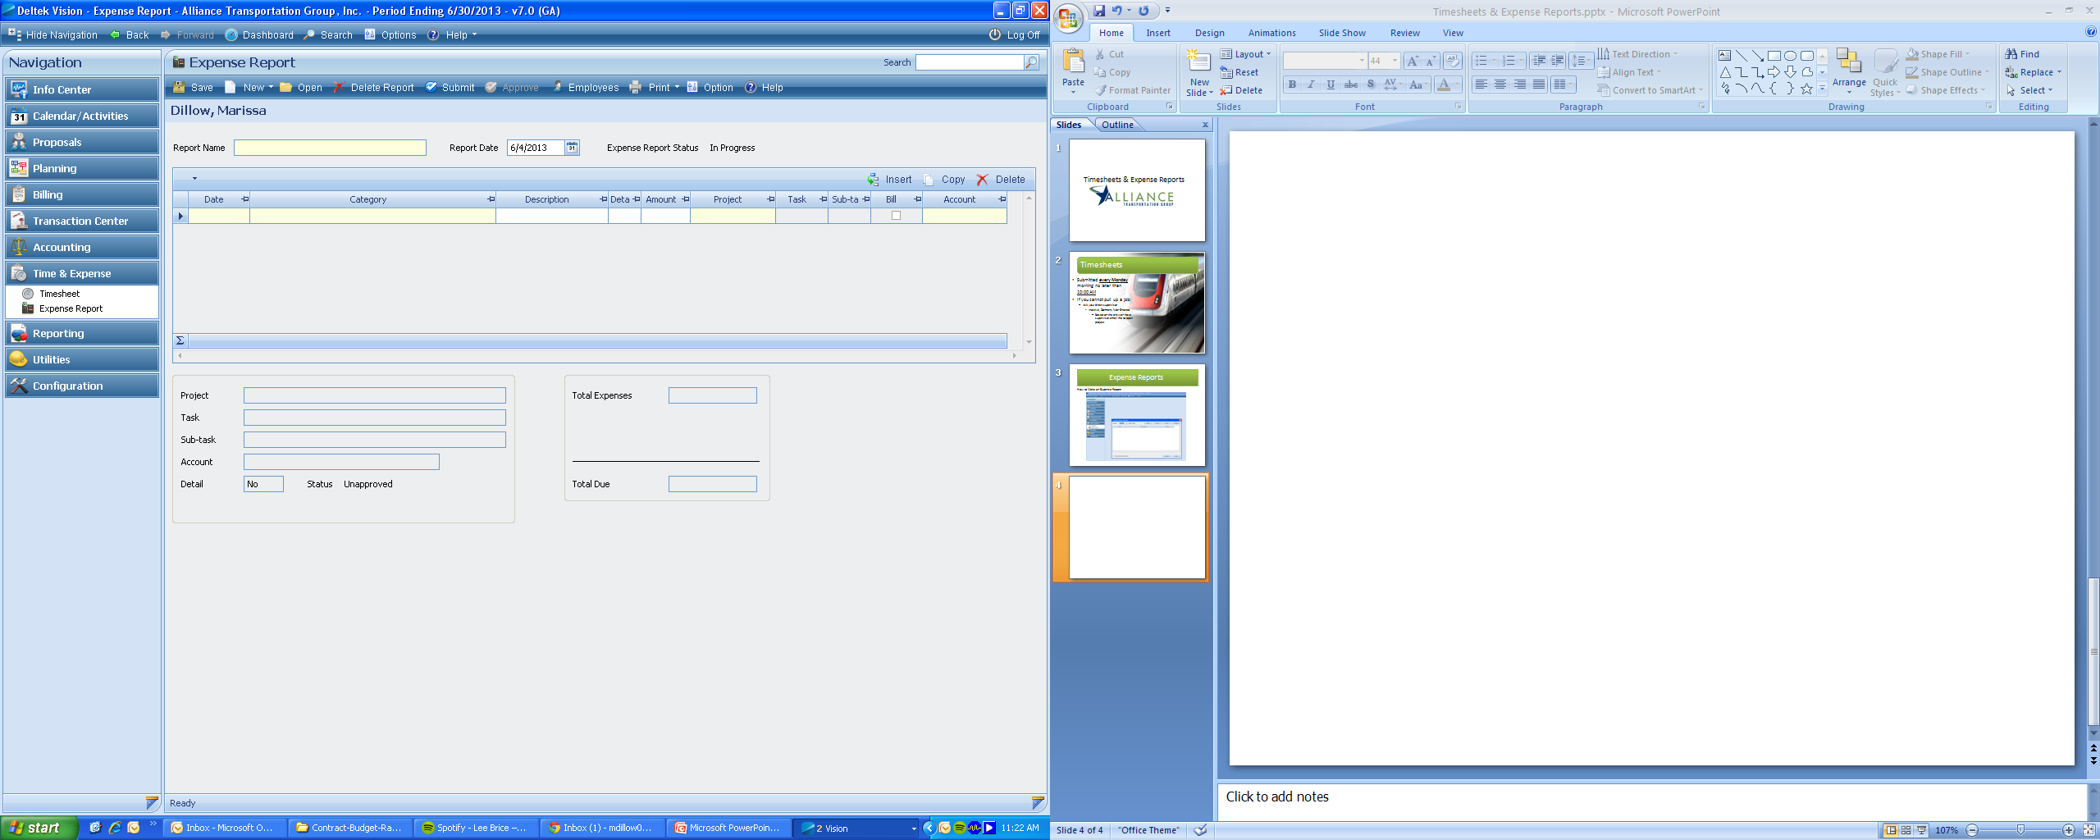

* **Report Name**: Choose a unique name for each report
* **Date**: Record the date expense was incurred
* **Category**: Choose from the drop down menu what category your expense fits in
* **Description**: Short description of the expense, EX “Lunch for MM”
* **Detail**: Enter the business reason for the expense, each person involved, etc (more detail later)
* **Amount**: Amount to be expensed- must have an itemized receipt or mileage to back up costs
* **Project**: Choose Project number or Overhead Account
* General OH : 0000-1000.0000
* Client OH: 0000-8000.0000
* **Task**: for PROJECTS- choose the Direct Expense task, for OH- choose the office location the expense was incurred for, not what office you work for
* Austin- Task 01
* Lake Charles- Task 02
* Dallas- Task 03
* Houston- Task 04

# Expensing mileage

* When submitting mileage you must record the following in the “Detail” section:
* Under Business Reason for Expense
* Where you started, where you went and why
* Under Travel From/ To
* Beginning odometer reading
* Ending odometer reading
* 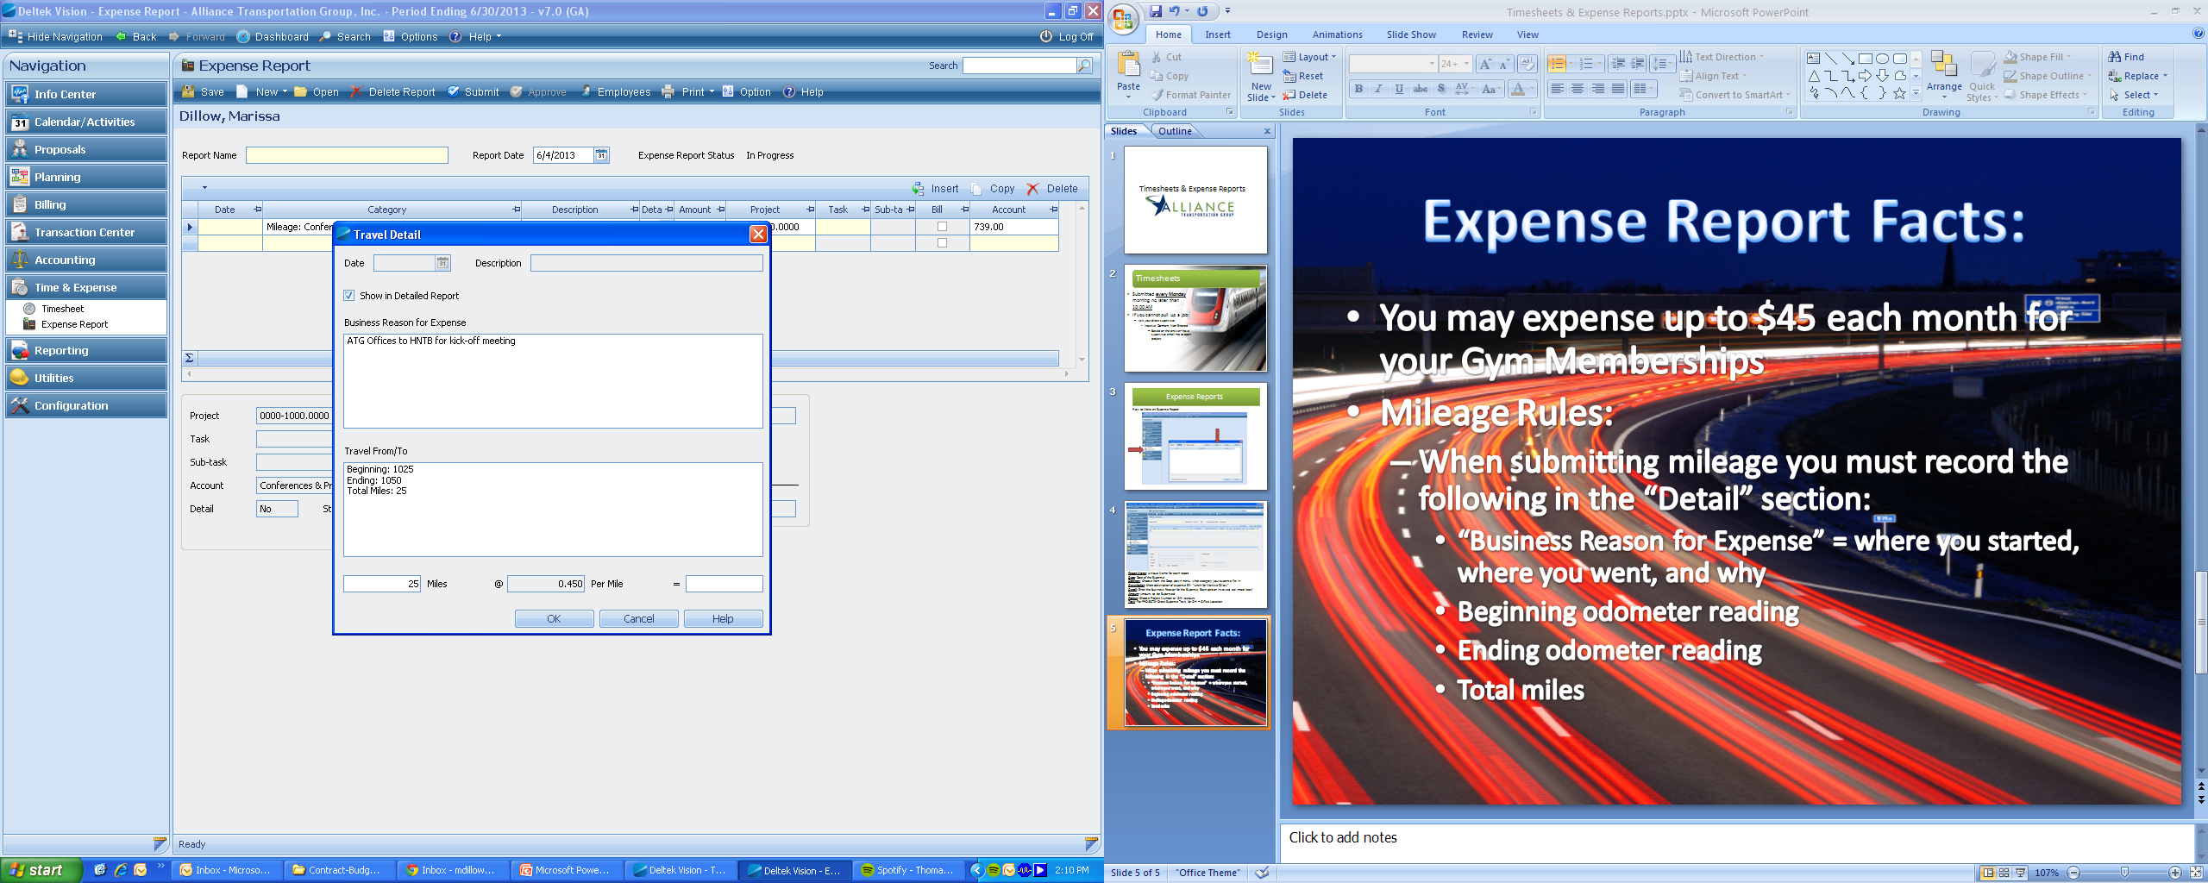Total miles
* Type the total mileage into the “miles box on the bottom left

# Expensing meals

* You **MUST** have an itemized receipt in order to be reimbursed.
* In the “Detail” section you must fill out
* Business Reason for Expense
* Short description of the Business reason
* Name of Each Person
* Every person that ate should be listed here. If they’re a non-ATG employee, please notate their business, EX: Steve Miller- HNTB
* If you’re expensing a meal for a **recruit**- please indicate which person is the recruit, what position they’re being recruited for, and for which office.
* The project that should be billed is the office you’re recruiting for. EX: You eat in Austin for an employee you’re recruiting for the Dallas office, the charge needs to go to the Dallas OH.

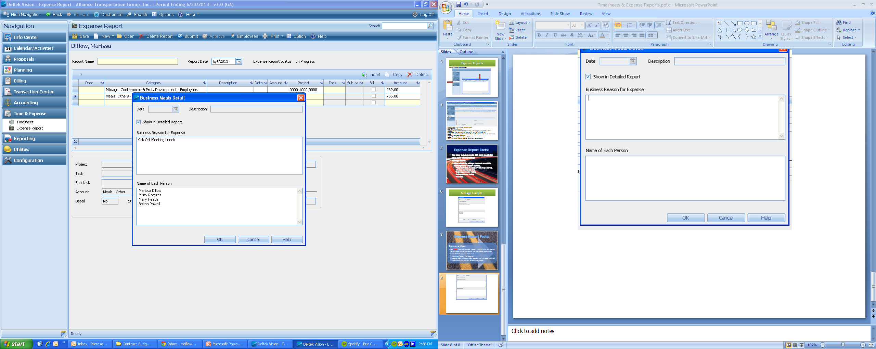

# submitting your expense report

* When you’re finished, please hit “SUBMIT”
* Print the **DETAILED** report, sign and attach copies of all receipts **IN ORDER** they appear on the expense report and turn into Accounting

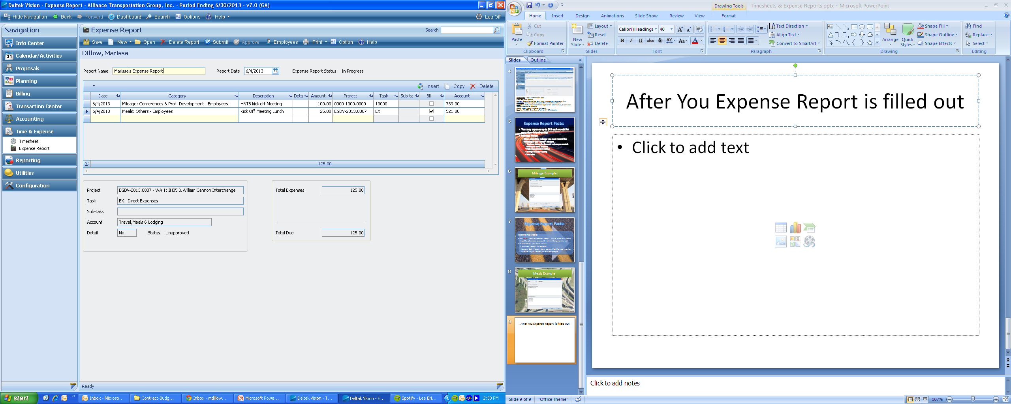

* **ALL Expense reports must be paper clipped together when submitted**. The expense reports are scanned after approval so staples do not work.

expense report receipts

* Please only tape the four corners of a receipt, any printing on a receipt you cover with tape will dissolve the ink, making it non-legible later on.
* Please only use yellow highlighter on any receipts; any other color makes the scans non-legible.
* All receipts must be taped to an expense **“Receipt Form”** found here:
* [Insert link to location of form]
* If your receipt is on a regular sheet of paper, an “Expense Label” can be put on your receipt. Accounting has labels pre-printed.

# Receipt form/ expense label

Project No: __________________Task:______

Allowable:

Unallowable:

Card No.­­­____________ Amount:___________

Person(s):______________________________

Expense Type:­­__________________________

Location:________________ Date:_________

Purpose:­______________________________

**Project number:** Do not cross this out, everything has a project number.

* OH- 0000-1000.000 (you can write just “OH” in the project number and that will be fine, you don’t have to write it out each time)
* Marketing/ Client Relations: 0000-8000.0000

**Task number:** Do not cross this out either- if it’s an OH project these are your task options:

1. Austin
2. Lake Charles
3. Dallas
4. Houston

**Card number:** If it is a company card- record the last 4 digits (only) of the card used

**Amount:** The full amount of the charge, tip, taxes, etc. included. The full amount should be recorded on your expense report even if the allowable project amount will be different.

**Person(s):** This is filled out when warranted. Meals, Conferences, Registrations, are ALL tied to someone; those names need to be written out.

**Expense type:** DO NOT WRITE OVERHEAD….Please describe the type of expense we’re incurring: Meals, Lodging, Airfare, etc…. Purpose is the detailed reason we incurred the cost….

                EX: Meals: **Expense type**: Meal, ***Purpose***: Management Meeting

                EX: Conferences: **Expense type**: Lodging, ***Purpose***: APA Conference

                EX: Flights: **Expense Type**: Airfare, ***Purpose***: TRB Conference

**Location:** The location this expense took place in, or was incurred

**Date:** The date the expense was incurred

**Purpose:** This is where the more detailed description will go. If this expense was a meal, what was the meal for? Etc.

**Allowable/ Unallowable:** Circle if you know. If you’re unsure just leave this blank and accounting will complete.

All of this information is required for audit purposes under FAR and TxDOT and external auditors.

*****ALSO- We use a lot of Acronyms (SWTA, TRB, APA, etc) the auditor will not know what this means even though we do- you can reference the acronym but the **FULL** name **MUST** be written on each receipt as well.